Colegio Inglés

List 1 Sep. 6th. 2021.
1. thief
2. steak
3. August is the first month of our school year.
4. Lassie was a famous collie.
5. Write a sentence in your notebook (where)
6. His beautiful painting and stories show his creativity.
7. Mt. St. Helens is a volcano that erupted.
8. The goose laid a golden egg.
9. friendlness
10. Write a sentence in your notebook (dangerous)
11. Dutch and Swedish settlers began colonies in Delaware.
12. William Penn founded the colony of Pennsylvania.
13. receipt
14. Labor Day is a September holiday.
15. I am thankful for my Christian school.
16. We often play kickball at recess.
17. We could have pizza or a sandwich for lunch.
18. Write in your notebook the definition of knowledge.
19. Write in your notebook the definition of discipline.
20. Arithmetic is my favorite academic subject.

Colegio Inglés

List 2 09-13-21
1. My neighbor is anyone whom I can help.
2. Sixty seconds make one minute.
3. There are one hundred years in a century.
4. Write in your notebook the definition of reign.
5. Nearly 300,000,000 people live in the United States.
6. Jesus is our Redeemer; He saved us.
7. Fish breathe through their gills.
8. eighty
9. Did you reduce your fraction to the lowest terms?
10. Write a sentence in your notebook with (decent)
11. Have you ever visited New Jersey?
12. Write a sentence in your notebook with (Georgia).
13. Emily did not win the race, but she came in second.
14. Beige is a pale brown color.
15. autumn
16. Write a sentence in your notebook (decade).
17. Learn the definition of each vocabulary word.
18. How many pounds does a rhinoceros weigh?
19. Our principal helped us during the fire drill.
20. His excuse was not believable.

Colegio Inglés

List 3 09-20-21
1. An honest person does not practice deceit.
2. Write a sentence in your notebook with (review).
3. A small balcony hung over the garden.
4. Write a sentence in your notebook with (ability).
5. She has a bruise on her knee after falling off her bike.
6. Elementary arithmetic students focus on addition, subtraction, multiplication, and division.
7. pedestrian
8. 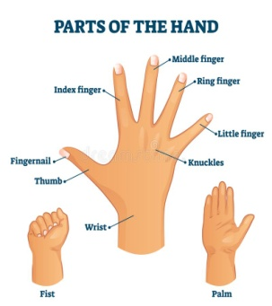knuckle
9. The men had to rescue the kitten from the tree.
10. Write in your notebook the definition of mischievous.
11. Thomas Hooker founded Hartford, Connecticut.
12. An interstate highway sometimes stretches from one end of the country to the other.
13. We towed our vehicle behind the moving van.
14. You should walk facing traffic if there is no sidewalk.
15. anniversary
16. Our galaxy, the Milky Way, contains more stars than you can count.
17. There is a new stoplight at the intersection of 4th. Avenue and King Street.
18. expressway
19. The conceited girl was filled with pride because of her athletic ability.
20. Andrew chose to live on campus rather than commute each day.

Colegio Inglés

List 4 09-24-21
1. The gigantic elephant towered above the tiny clown.
2. pier
3. My cousin Daniel will spend a week with us this summer.
4. Satan is the enemy of every child of God.
5. There are many orange groves in Florida and California.
6. I love the fourth grade!
7. The enemy took the city by surprise at mid-night.
8. A cow’s stomach has four compartments.
9. The minister of my church is a godly man.
10. 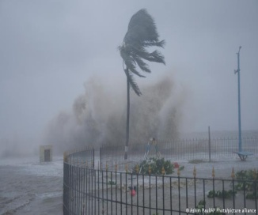 cyclone
11. Write a sentence in your notebook with (Massachusetts).
12. Write in your notebook the definition of grieve.
13. 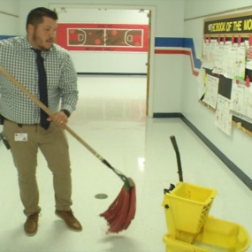 janitor
14. Write in your notebook the definition of tithe.
15.
16. Aspirin tablets help relieve pin.
17. Madison will accompany Emma on the piano as she sings.
18. Write a sentence in your notebook with (ceiling).
19. The preacher will baptize ten people today.
20. “Onward, Christian Soldiers” is a favorite hymn.

Colegio Inglés

List 6 10-11-21
1. Write a sentence in your notebook with (absence).
2. We enjoyed the excitement of the first assembly.
3. Write in your notebook the definition of committee.
4. Isaiah divided the pie exactly in half.
5. I have not forgotten the Bible verses.
6. Write in your notebook the definition of awkward.
7. Write a sentence in your notebook with (miniature).
8. caution
9. Wednesday is the fourth day of the week.
10. Nicholas spelled every word on his test without an error.
11. New Hampshire is called the Granite State.
12. Virginia is one of the thirteen original colonies.
13. lawyer
14. Write in your notebook the definition of vacuum.
15. Mother is planning a special Sunday dinner.
16. Sherlock Holmes solved the mystery of the painting´s disappearance.
17. 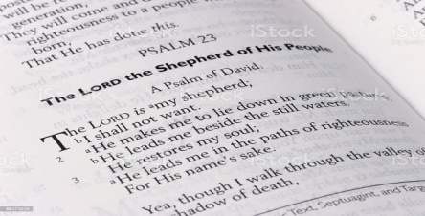 psalm
18. Olivia controlled her temper.
19. Oranges are naturally sweet.
20. After winning the game, the team cheered.
21. Susannah Wesley taught all of her children to read.
22. Mr. Sylvester has two sons and one daughter.
23. Write in your notebook the definition of seldom.

Colegio Inglés

List 8 10-25-21
1. Dr. is the abbreviation for doctor.
2. Write in your notebook the definition of quitter.
3. After the baby’s bath, Mom wrapped him in a towel to dry.
4. Write a sentence in your notebook with (toward).
5. A water-filled moat surrounded the castle.
6. I like to have lettuce on my tuna sandwiches.
7. spinach
8. cauliflower
9. Grandmother is knitting me a sweater.
10. Rhode Island was founded by Roger Williams.
11. The states surrounding Vermont are New York, New Hampshire, and Massachusetts.
12. Write a sentence in your notebook with (shipment).
13. Does this store sell men’s apparel?
14. credit card
15. We will advertise our yard sale in Saturday’s paper.
16. clearance
17. My favorite birthday gift was a Gap gift certificate.
18. The greedy child was a glutton.
19. An untidy person is not particular about his appearance.
20. fragrance
21. A fungus attacked the field of wheat.
22. It is necessary to do your homework each evening.
23. The principal made an announcement over the intercom.

Colegio Inglés

List 11 11-22-21
1. A headache might be a symptom of eyestrain.
2. Write a sentence in your notebook with the word unknown.
3. Proverbs 9:8 says, “Reprove not a scorner, lest he hate thee: rebuke a wise man, and he will love thee”.
4. biscuit
5. Write a sentence in your notebook with the word pyramid.
6. limousine
7. Which volume of the encyclopedia do you have?
8. A dictionary gives information about marking a word’s syllables.
9. I like to associate with other Christians.
10. We vacationed in the Smokey Mountains of Tennessee.
11. Ohio is known for its large resources of coal.
12. Write in your notebook the definition of conference.
13. Sherlock Homes quickly solved the mystery.
14. university
15. mirror
16. Jackson had his tonsils removed at the hospital.
17. Plants give off oxygen into the air during photosynthesis.
18. exercise
19. applause
20. Write in your notebook the definition with the word happiness.
21. 90 ninety
22. There are one hundred years in a century.
23. Three cents are really three hundredths of a dollar.

Colegio Inglés

List 11 11-22-21
1. A headache might be a symptom of eyestrain.
2. Write a sentence in your notebook with the word unknown.
3. Proverbs 9:8 says, “Reprove not a scorner, lest he hate thee: rebuke a wise man, and he will love thee”.
4. biscuit
5. Write a sentence in your notebook with the word pyramid.
6. limousine
7. Which volume of the encyclopedia do you have?
8. A dictionary gives information about marking a word’s syllables.
9. I like to associate with other Christians.
10. We vacationed in the Smokey Mountains of Tennessee.
11. Ohio is known for its large resources of coal.
12. Write in your notebook the definition of conference.
13. Sherlock Homes quickly solved the mystery.
14. university
15. mirror
16. Jackson had his tonsils removed at the hospital.
17. Plants give off oxygen into the air during photosynthesis.
18. exercise
19. applause
20. Write in your notebook the definition with the word happiness.
21. 90 ninety
22. There are one hundred years in a century.
23. Three cents are really three hundredths of a dollar.

Colegio Inglés

List 12 12-01-21
1. difficulty
2. Write a sentence in your notebook with the word champion.
3. The strong man could lift even the heaviest weights.
4. The wax is dry, and it is now permissible to walk on the kitchen floor.
5. hurried
6. Our word typhoon comes from a Chinese word that means “big wind”.
7. circular
8. Do not criticize a person until you know all the facts.
9. analyze
10. missionary
11. Louisiana
12. sugar
13. tidiest
14. dynamite
15. conversation
16. victorious
17. reputation
18. encyclopedia
19. gymnasium
20. congratulations
21. The room with the fireplace is cozier than the study.
22. Nursery rhymes would be good examples of fanciful stories.
23. Water from hydrants is used to put out fires.

Colegio Inglés

List 15 01-10-22
1. quite
2. Write a sentence in your notebook with the word satisfied.
3. Curiosity killed the cat.
4. I often help Mom by carrying in the groceries.
5. Write in your notebook the definition of against.
6. brilliant
7. scientific
8. abundant
9. Write a sentence in your notebook with the word effort.
10. avoid
11. Illinois
12. Alabama
13. all right
14. quiet
15. supplying
16. entertaining
17. assigment
18. exciting
19. opportunity
20. astonish
21. fried
22. Georgia is a southern state.
23. Isaac married Rebekah.

